DECLARATION

We hereby declare that this project for the degree of Bachelor in Science Education (Geography) has been written by us and it is a record of our own research work. It has not been previously presented either wholly or partially for any degree and is not being concurrently for any other degree.

All quotations are indicated and the sources of information are specifically acknowledged by means of references.

JIMAH ABDULKADIR MUHAMMAD

HASSAN ABUBAKAR

ESTHER ODACHE OCHE

CERTIFICATION

This project entitled ‘’The Application of GIS Techniques in Locating and Creating of Data Base of Senior Secondary Schools Laboratories in Giwa Educational Zone, Kaduna state, Nigeria’’, meets the regulations governing the award of Degree of Bachelor in Science Education (Geography) of Ahmadu Bello University, Zaria and is approved for its contributions to knowledge and literacy presentation.

Project supervisor

Dr. (Mrs.) Binta Abdulkareem.

Head of Science Education

Prof Mamman Musa

Dean Faculty of Education

Prof Dalhat Tijjani.

DEDICATION

This project work is dedicated to our parent.

AKNOWLEDGEMENT

A lot of people have in one way or the other contributed to this work. It is not possible to mention all of them on this paper, however only a few will be mentioned.

First we owe a lot of thanks and glorifications to Almighty God who used Dr (Mrs.) Binta Abdulkareem of Ahmadu Bello University, Zaria, department of science education for her tireless constructive criticisms and guidance throughout the course of this research.

We will also like to thank our lecturers such as Rev (Dr.) S.S Obeka, Dr S.S Bichi, Dr. (Mrs.) T.E Lawal, Dr (Mrs.) Olorukoba and Dr (Mrs.) F.K Lawal for their various contributions in our study.

We are also grateful to our beloved parent and others who are not mentioned.

**CHAPTER ONE**

1. INTRODUCTION

Education is one of the vital tools that can facilitate Nigeria to become a large economy by the year 2020. However, the trends in Nigeria’s educational development revealed a state of stagnation within all levels of education, namely; Primary, Secondary and Tertiary (NPC 2009).

A geographic information system (GIS) is a computer system designed to capture, store, manipulate, analyze, manage and represent all types of geographic data. GIS can be thought of as system that provides spatial data entry, management and retrieval, analysis and visualisation function.

Also, geographic information system is a computerized data management system used to capture, store, manage, retrieve, analyze, and display spatial information. Data captured and used in a GIS commonly are represented on paper or other hard-copy maps.

It is also a “system for management, analysis, and display of geographic knowledge, which is represented using a series of information set such as maps and globes, geographic data sets, processing and work flow models, data models, and Meta data” (ESRI, 2004).

The use of GIS in the study will facilitate, identify location, patterns and types of facilities in the study area.

Remote sensing and geographic information techniques can be used to answer the question of what is located at a given point on the earth, where a specific feature is located and possibly the relationship between the phenomena and human activities. In essence the process of GIS and remote sensing try to answer the question of ‘what’ ‘where and how the phenomena in study is related to human activities which could help in making decision. These techniques tend to collect, process, analyze and present data of the phenomena of study. For instance, using a mouse driven cursor, a specific point on a map can be queried to determine its land use, vegetation, soil type, elevation and ownership characteristics. Similarly, soil data across an entire watershed can be queried to determine the distribution of areas with hydric soil of greater than 100acres and are adjacent to a major river system. In the first case, a specific known point was queried to determine preselected attributes. In the second case, however, specific locations were not known. Rather, the database was searched by the GIS to determine where specific conditions were satisfied.

Remote sensing on the other hand implies the acquisition of information about an object or phenomenon without making physical contact with the object and hence in contrast to in situ observation. In modern usage, the term generally refers to the use of aerial sensor technologies to detect and classify object on earth by means of propagated signals. It may be categorized into active remote sensing, when signal is first emitted from aircraft or satellite or passive, when information is merely recorded.

Moreover, a laboratory is a building, part of a building or other place equipped to conduct scientific experiments, tests, investigations, observation, development scientific laws and theories through analysis of data. A laboratory could either be dry or wet in it types. The former implies a place where chemicals, drugs, or other materials or biological matter are handled in liquid solution or volatile phases, requiring direct ventilation, and specialised piped utilities whereas the later implies a laboratory where computational or applied mathematical analysis are done on a computer-generated model to stimulate a phenomenon in the physical realm whether it be a molecule changing quantum states, the events horizon of a black hole or anything that otherwise might be impossible or too dangerous to observe under normal laboratory condition. This term may also refer to lab that uses primarily electronic equipments.

The consequence of low achievements in public examination is the inability of learners to be exposed to effective teaching methodology and teaching materials. As a result of this poor performance, stakeholders in education are curious to know the causal factors associated with the problem. Causes of the poor academic performance could include ownership of the school and inadequate facilities. Facilities are of everything used directly or indirectly for the benefit of education. Facilities could also be explained as the entire school plant such as blocks of classrooms, staffrooms, laboratories, workshops, libraries, laboratory equipment, consumables, audio-visual aids, electricity, water, chairs, tables, stationeries, playground, storage spaces and others which school has. It has always been realized that facilities are very important in the development and improvement of education in Nigeria. A school without facilities, either private or public, may not be able to achieve the stated goals and objectives of the system. When facilities are available and skillfully utilized, they influence learning and making it more meaningful. Facilities in education are very vital because they aid teaching and learning (Bamidele, 2003)

1.2 OBJECTIVES OF THE STUDY.

The aim of the study is to identify the pattern and location of laboratory facilities of Senior Secondary Schools in Giwa Educational Zone of Kaduna state. Specifically, objectives to this study are to

1. Map out the location of schools and laboratories in the study area
2. Identify the categories of laboratories in the study area
3. Identify the kinds of laboratory facilities in the study area.

1.3. RESEARCH QUESTIONS

1. What are the location and patterns of schools and laboratories in the study area?
2. What categories of laboratories exist in the study area?
3. What kinds of facilities exist in the laboratories?

1.4 STATEMENT OF PROBLEM

Research work and studies have been carried out using GIS and remote sensing techniques. In the form of landuse, solve security challenges; map out location infrastructure, among other.

In the works of Abbass (2012), created a database management and mapped out education infrastructure in Sabon – Gari and Zaria Local Government Area where he used Germin 75S attached GPS received to obtain the coordinates of all the schools (secondary schools). Questioners and digital base map was obtained by digitizing Google pro2 satellite for further analysis and concluded that virtually all the schools are ill equipped with facilities to promote adequate learning processes in the schools and there is need for government and non-government agencies and organization to help so as attain the nations stated educational objectives.

Isioye et al (2012) used GIS to analyze the terrain of Basawa Community of Sabon Gari L.G.A of Kaduna with respect of surface runoff and GPS and total/station was used to obtain co-ordinates from traverse survey, and DEM and DTA was used to create and quantity the analysis of the virtual environment and by which they concluded that floodings is the major hazard recurring in that area it is always as a result of poor drainage channels and the flatness of the slope in the residential quarters.

Ogolowa (2006) also maintained the use of GIS and remote sensing techniques to monitor the rate and effect of urbanization in Sabon – Gari L.G.A of Kaduna between the 1976 – 1996 and used the organized flow chart for his data analysis and concluded that there has been raped urbanization over the years and as such there has been over use of resources and scarcity of land for agriculture, and industrial development.

Damkara (2010) also used GIS to map out the distribution of Zain base station ion Kano where he used the cartographic model to present his findings.

In view of the above studies, the research work will focus on creating a data base of senior secondary school laboratories in Giwa educational zone of Kaduna State.

1.5 SCOPE OF THE STUDY

This study will be carried out in Giwa educational zone of Kaduna State where GIS and remote sensing techniques will be used to create database of senior secondary school laboratories within the time of one year.

1.5. SIGNIFICANCE OF THE STUDY A GIS database for public secondary school in Giwa local government area of Kaduna state will be of great importance to the state government as well as the cooperation of all Nigerians, non- governmental organization and private sector in achieving objectives of education. It is extremely important to access the facilities through the use of a GIS database. With this database there is a potential to improve efficiency of schools through the planning and management of resources and the display of geographic knowledge. Analysis from the database can be carried out in several significant ways.

A GIS database created can assist the present government in proper distribution of schools, improve the existing infrastructure and provide additional infrastructure for planning and management of educational resources.

It also brings the classroom to life by aiding students to see the world and its altitudes right on a screen in front of them, encourage critical thinking among students and makes teaching and learning process less time consuming.

**CHAPTER TWO**

**REVIEW OF RELATED LITERATURE**

**2.1 CONCEPT OF GIS AND REMOTE SENSING**

There has always been a paradigm shift in the field of geography. It has moved from what was termed as modern geography to information geography or geo-formatics, where software and hardware are used to process, analyze and present data. This, invariably enhance transformation to be taking place for which Business and government, schools and hospitals, non profit organization and other are taking advantage of it. All around the world people are working efficiently because of it. These transformations are however enhanced through the use of GIS and Remote sensing and techniques.

Remote sensing and geographic information system techniques can be used to answer the question of what is located at a given point on the earth, where a specific feature is located and possibly the relationship between the phenomena and human activities. In essence, the process of GIS and remote sensing try to answer the question of “what” where and how the phenomena in study is related to human activities which could help in making decision. The techniques tend to collect, process, analyse and present data of the phenomena of study. For instance, using a mouse driven cursor, a specific point on a map can be querried to determine its land use, vegetation, soil type, elevation and ownership characteristics. Similarly, soil data across and entire watershed can be queried to determine the distribution of areas with hydric soil of greater than 100 acres and are adjacent to a major river system. In the first case, a specific known point was queried to determine pre-selected attributes. In the second case, however, specific location were not known, rather, Database was searched by the GIS to determine where specific condition were satisfied. It is however important to know that the creation of data base is the heart of GIS processing techniques.

The importance of remote sensing and GIS has been overwhelming which has compelled curriculum innovators to include GIS and remote sensing concept in Geography for O’ level studies, so as to keep abreast the changing situation of the subject.

A Geographic information system is a computerized data management system used to capture, store, manage, retrieve, analyze and display spatial information. Data captured in GIS are commonly represented on paper or other hard copy maps.

A GIS differs from other graphics system in several ways or respects. First, data are geo referenced to the coordinate of a particular projection system. This allows precise placement of features on the earth’s surface and maintain the spatial relationships between mapped features. As a result commonly referenced data can be overlaid to determine relationship between data elements. For example soil and wetland for an area can be over laid and compared to determine the correspondence between hydria soil and wetland. Similarly, land use date for multiple time periods can be overlaid to determine the nature of changes that may have occurred since the original mapping. This overlay function is the bares of change diction studies across landscapes and with these analysis of overlaying prediction of the future can be made on the consequences of the phenomenon in study.

Secondly, Gis software use relational database management technologies to assign a service of attributes to each spatial and attribute data between tables A soil polygon. For example, can be linked to a service of database tables that define its mineral and chemical composition crop field. Land use satiability slope, and other characteristics.

Equally important, the software provide the capability to combine various data into a composite data layer that may become a base layer in a database .For example, slope, soil, hychography, demography, wetlands, and land use can be combined to develop a single of suitable layer hazardous waste storage sites. These data, in twin, may be incorporated into the permanent database of a local government and used for regulatory and planning decisions.

Also, so the software generally allow for two types of data. Some use raster data (i.e discrete cells in a rigid row by column format),such as satellite imagery or avoid photography, while others use vectors(points, lines and polygons)to represent features on the earth surface. Most systems allow for full integration of both types of data. In either case a fully functioning GIS allows the use to enter or digitize data that are geo-referenced (Arch GIS),link specific attributes to each feature using relationship between various geographic features using a wide range of spatial operation function, and produce high resolution images or graphics on color monitors or porters.

2.2 **FUNCTION OF GIS**

One of the most powerful function of a GIS is that is allows uses to synthesize or combine different layers of information to identify distribution patters that may otherwise not be obvious. For example using various map overlay techniques, threatened and endangered species data may be combined with wetland information to determine if any of the preshroates tidal wetlands in an area provide habital for sensitive or critical species. This information could be used to identify areas where the reintroduction of a threatened or endangered species might be successful. This information also can be used in the design of swilled stiategies and methods to focus on areas of potentials threatened and endangered species location.

Also, it can be used for complex modeling to answer a wide range of ‘’what of’’ and ecosystem simulation questions. These may be cartographic models designed to documents the coocuvience of inter-relationship of multiple date layers or they may be hypothetical research models designed to mimic natural ecological systems. Similarly, modeling with GIS can be used to predict the impact that one set of parameters will have no another for example, wetland, soils, climatology, hydrography and elevation data can be combined to model flooding within a river system. Upstream changes in land use within the same system can be modeled to determine the potential impacts of human land use decision can be assessed prior to the proposed actions.

Regardless of the application in which GIS technology is used these system provides rapid data access and multidimensional analysis and graphical output capabilities that can result in more effective resource management decisions.

**2.3 GIS APPLICATION AND MAPPING**

Geographic Information System (GIS), computer system that records, stores, and analyzes information about the features that make up the earth's surface. A GIS can generate two- or three-dimensional images of an area, showing such natural features as hills and rivers with artificial features such as roads and power lines. Scientists use GIS images as models, making precise measurements, gathering data, and testing ideas with the help of the computer.

Many GIS databases consist of sets of information called layers. Each layer represents a particular type of geographic data. For example, one layer may include information on the streets in an area. Another layer may contain information on the soil in that area, while another records elevation. The GIS can combine these layers into one image, showing how the streets, soil, and elevation relate to one another. Engineers might use this image to determine whether a particular part of a street is more likely to crumble. A GIS database can include as many as 100 layers.

A GIS is designed to accept geographic data from a variety of sources, including maps, satellite photographs, and printed text and statistics. GIS sensors can scan some of this data directly-for example, a computer operator may feed a map or photograph into the scanner, and the computer "reads" the information it contains. The GIS converts all geographical data into a digital code, which it arranges in its database. Operators program the GIS t6 process the information and produce the images or information they need.

The applications of GIS are vast and continue to grow. By using a GIS, scientists can research changes in the environment; engineers can design road systems; electrical companies can manage their complex networks of power lines; governments can track the uses of land; and fire and police departments can plan emergency routes. Many private businesses have begun to use a GIS to plan and improve their services. The Canadian government built the first GIS, the Canada Geographic Information System, during the 1960s to analyze data collected by the Canada Land Inventory. Other governments and university laboratories social built similar systems. However, GIS systems were not widely used until the liter 1970s, when technological improvements and lower costs made computers widely available. GIS sales boomed during the 1980s, as governments and businesses found more uses for tile systems. A number of companies began producing new GIS software to program computer systems to increase their functions. By the early 1990s, about 100,000 GIS systems were in operation.

Maps are the main source of data in GIS, Mapping has improved through the use of remote sensing techniques, such as radar and infrared mapping from aircraft and satellites, and this in turn has helped geographers better understand the earth. Geography can now determine latitude and longitude positions on the earth by using the global positioning system of satellites (GPS). Map information can now be stored digitally, as in geographic information systems (GIS). Subsurface, or underground, mapping is becoming more common. This technique uses drilled cores and sound waves sent below the ground to map structures such as fault.

**2.4 Schools Physical Facilities to Ensure Educational Performance**

Schools are established for the purpose of teaching and learning. It is more important that the teachers and learners are properly accommodated to facilitate the teaching that go on there. This is the essence of the school plant and facilities (Alimi 2004). Therefore school facilities are the space interpretation and physical expression of the school curriculum.

In Nigeria at large, secondary schools, irrespective of ownership are expected to function in compliance with the achievement of the national education objectives. To this end, students are expected to perform brilliantly in the final examination as this determines the quality of output of secondary schools. This is one of the parameters used to measure the effectiveness of a school system. The better the performance of the students, the more effective the system is expected to be (Philias and Wanjobi 2011).

In another related study, Cynthia and Megan (2008) confirmed a strong and positive relationship between quality of school facilities and students achievement in English and Mathematics in Nigeria, it is the general opinion of people that private schools are better in terms of the availability of human and physical facilities and consequently student’s performance than public schools. Experience has however, shown that most student who secure admission into tertiary institution are from private school and this situation have made many percent to enroll their children into private rather than public schools. The rate of poor academic performance of students in the country had resulted to economic and social wastage and this have become a great concern to all stakeholders in education. For example, in 2008, 25, 94% of the students had credits pass in English language and Mathematics (Alimi etal 2011).

The consequences of mass failure in public examination are the inability of learners to proceed to higher educational institution. As a result of this poor performance, stakeholders in education are curious to know the causal factors associated with the problem. Causes of the poor academic performance could include ownership of the school and inadequate facilities. Facilities are of everything used directly or indirectly for the benefit of education.

Bandele (2003), noted that the importance of physical facilities cannot be relegated. Facilities like modern laboratories, libraries and classroom are to be put in place in all our schools Adesola (2005) found out that the level of available resources indeed a plus to the teachers and goes to show the level of ingenuity and commitment of the teachers toward effective delivery of lesson. As recommended by Alimi (2007), theare is the need for renovation of old buildings, chairs, desks, cabinets, and acquisition of modern classrooms. Akinfolarin (2008) also identified that facilities are major factor contributing to academic performance in the schools system, these facilities include classroom, furniture, recreational equipment among others. Different studies conducted by Ayodele (2000) and vandiver (20011), showed that a positive relationship exist between availability of facilities and students academic performances.

Research findings on the influence facilities in private and public secondary schools on Students academic performance are controversial. Keeves (1978) found out that the type of school, classified as public or private did not make any difference on Student’s academic performance.

Moreover Ajayi (2006) found out that school type make a difference in students’ academic performance. In addition, Philia and Wanjobi (2011) reiterated that the type of school (single sex or mixed, private or public) has effect in the academic performance of students.

By and large, school facilities themselves hinder rather than enhance good teaching practice. School facilities in most Nigerian school today are apt to reinforce role teaching methods and further hinder the student capacity for independent and creative thinking. The typical school building in Nigeria is usually a simple row of bare classroom structures often of rectangular shaped walls in which chairs, tables, and students must all fight for space. Bare plaster walls and cement floors become echo chambers for chairs scraping against floors, pencils tapping on tables on tables and children whi8spering. Tables and benches or chairs do not lend themselves to small group or individual work but often encourage a formal spatial relationship between teachers and learner, thereby enhancing role learning and group thinking.

Often there is little or no storage space for class books, papers, projects, not to mention each child possessions. What develops is the loss of sense of privacy and insecurity of property often experienced in a situation that should otherwise teach continuity and consistence. School consequently serves an image of insecurity and uncertainty which is ironical. Sicne the school is a centre where children are supposed to be exposed to the certainty of the prevailing assumptions and values of his society (Dopemu 2011).

**2.4 USE OF LABORATORIES**

According to Wikipedia, the free encyclopedia, a laboratory is a facility that provides controlled conditions in which scientific or technological research, experiment and measurement may be performed. However, laboratories used for scientific research take many forms because of the differeing requirement of specialist in the various fields of sciece and engineering. For example, a physics lab might contain a particle accelerator or vaccum chamber, while a metallurgy lab may have apparatus for casting or refining metals or testing their strength. A chemist or biologist might use a wet laboratory, while a psychologist lab could use a room with one-way mirrors and hidden cameras in which to observe behavior. In some labouratories, such those commonly used by computer scientist. Computer (sometimes super computers) are used for simulation or the analysis of data collected elsewhere.

In addition, scientific laboratories can be found in schools and universities, in industries, government or military qualities and even aboard ships and spacecrafts. A laboratory might offer space for just one to more than thirty researchers, depending on its size and purpose.

**2.5 TYPES OF LABORATORIES**

Generally, there are two types of laboratories viz: Dry laboratories and wet laboratories. The former implies a form of laboratory where computational or applied mathematical analysis are done on a computer generated model to stimulate a phenomenon in the physical realm whether it be in a molecule changing quantum state, the events horizon of a blak hole or anything that otherwise might be impossible or too dangerous to observe under normal laboratory condition. This term may also refer to lab that uses primarily electronic equipment whereas the later connotes a place where chemicals, drugs or other materials or biological matter are handled in liquid solution or volatile phases, requiring direct ventilation and specialized piped utilities (free encyclopedia).

In the submission of Samba and Eriba (2011), identified three types of laboratories. They are:

a) The single laboratories

b) Multi-purpose laboratories

c) special purpose laboratories

The single purpose school laboratories is the one which is designed and equipped for teaching only one science subject. An example of this is the biology, chemistry, physics or integrated science laboratory.

The multipurpose school science laboratory is designed for the teaching and learning more than one science subject; the laboratory is usually designed and equipped for the purpose of carrying out scientific experiments in more than one science subject. Though not at the same time, in the multipurpose science laboratory features and provision of single purpose laboratories could be identified or seen in the same room. The multipurpose laboratories in schools are necessitated by the paucity of funds by proprietors of schools. Hence, multi-purpose school science laboratory is a common feature in public/community/private proprietory schools in Nigeria.

Equally important spacial purpose laboratory is one that is designed for research purposes and this type of laboratory is usually found in universities and even at that it is meant for post-graduate research student.

Recently, a new type of laboratory called open laboratory has emerged, it’s a format that allows the sharing of space, equipment, support staff between different research groups and also fosters information exchange through communications across fields. There is also an open source lab, which is lab that is made up of open source scientific hardware. (free encyclopedia).

**2.6 ROLES OF LABORATORIES**

Science educators have believed that the laboratory is an important means of instruction in science, since late in the 19th century. Laboratory activities were used in high schools chemistry in the 1880s (Fay, 1931). In 1886, Havard universities published a list of physics experiment that were to be included in high school physics classes for students who wished to enroll at Havard (1976). Laboratory instruction was considered essential because it provided training in observation, supplied detailed information and aroused pupils interest . these same reasons are still accepted almost 100years later.

Shulman and Tamur (1973) listed five groups of objectives that may be achieved through the use of the laboratory in science classes.

1. Skill- Manipulative, inquiry, investigative, organizational communicative.

2. Concept for example, hypotheisis, theoretical model and taxonomy category.

3. cognitive abilities- Critical thinking, Problem solving, application, analysis and synthesis.

4. Understanding the nature of science- Scientific enterprise, scientists and how they work, existence of a multiplicity if scientific methods inter-relationships between science and technology and among the various disciplines of science.

5. Attitudes for example, curiosity, interest, risk taking objectivity, perseverance, satisfaction, responsibility, consensus, collaboration and above all liking science.

**2.7 CURRENT TRENDS OF SCIENCE LABORATORIES TO STUDENTS’ PERFORMANCE IN NIGERIA**

One of the fundamental problems facing science teaching today is the question of how current are the professional teachers. The majority of teachers who have been employed in the past decades have been doing the same way all along. They have no knowledge of the current ideas and innovations that have taken place in the educational field in the recent past. What account for this is that teachers have not been give the opportunity for re-training (Ogunbiyi 2004). He therefore recommended that teachers should be encouraged to go for workshop in their field of specialization.

Laboratory adequacy however, which is a school environment factor has been reported to affect the performance of students in chemistry (Raimi. 2002 and Adeyegbe, 2005).

Farounbi (1998) argued that students tend to understand and recall what they see more than what they hear as a result of using laboratories in the teaching and learning of science.

In Nigeria, the pupil’s home upbringing tends to affect their attitudes towards authority; it is one of cooperation and passive submission. Children seem to have natural tendency to explore, find out and collect objects. Too much restriction can have a lasting effect on the learner to the extent that he becomes afraid to experiment and explore in chemistry (science) and later in life when encouraged to find out for him or make individual contribution. He may be too inhibited to do so (Lawis and Eddy 1967). Kahl(1961 has shown that parental attitudes were more important in predicting aspiration of pupils towards continuing their schooling and successes in school than status. They should therefore discuss the progress of their children with the teachers so as to assist in their areas of difficulties, especially science oriented subjects.

However, it is disappointing to note that the students’ performance in chemistry (science) at internal or external examination has remained considerably poor despite the relative importance of science(chemistry),(Saage 2009).several factors have been advanced to affect student poor performance.(Lorau(2006) reported that such include the student factor, teacher factor, societal factor. The governmental infrastructural problem language problem examination body related variables , curriculum related variables. (Saage 2009), identified specific variables such as poor primary school background in science. Lack of incentives for test, lack of interest on the part of students, students not interested in hard work, incompetence teachers in the primary school , large classes ,fear of subject psychotically etc.

Moreover, as a result of bribery and corruption, unwillingness from the hands of government to improve laboratory facilities, poor science teachers in secondary schools and as well the institution of maximizing profit of proprietors of secondary schools has continue to create a scar on the state of laboratories in Nigeria which has affected students performance in science oriented subjects.(Abdulkadir 2014).

By and large, the enviable position which science education system of most countries of the world, including Nigeria is perhaps justifiable. The reason is that science can exert a dominant, If not decisive influence on the life of individual as well as on the development of a nation (emanon, 1985) .the universal recognition of the above submission is responsible for the prime position that has been accorded to science worldwide .within the context of education ,science subjects has been identified as very important in scientific and technological development of any nation has been widely reported. Effective science teaching can lead to the attainment of scientific and technology greatness

**CHAPTERTHREE**

**RESEARCH METHODOLOGY**

**3.0 INTRODUCTION**

This chapter provides the location and characteristics of the study area. It also outlays the study design, population of the study, sampling and sampling activities, instruments of data collection and as well as method of data analysis.

**3.1 CHARACTERISTICS OF THE STUDY AREA**

**3.1.1 Location of Study Area**

Giwa educational zone covers three Local Government Areas namely; Giwa, Sabon Gari and Kudan Local Government Area. It is located between latitude 10050’ 0’’N and 11020’ 0’’N and longitude 7010’ 0’’E and 7050’ 0’’E of the Greenwich Meridian. It is bounded to the east by Makarfi, Zaria metropolis to the south and Soba, to the West by Birnin-Gwari and Sabuwa, to the Northwest by Dandume in Katsina state and to the North East by Rogo Local Government Area in Kano state.

**3.1.2 Relief, Geology and Drainage**

The bedrock of the study area is predominantly metamorphic rocks of the Nigerian basement complex, consisting of biotite gneisses and older granites. In the southern eastern corner of the area contains the younger granites and batholiths are evident. Deep chemical weathering and fluvial erosion influenced by the bioclimatic nature of the environment have developed the characteristic high undulating plains with subdued interfluves high grades lateritic ironstone especially in the northwest.

However, rocky granite residuals from inselberges of varying shape and constitute the main local relief (relative relief is less than 150m) here and there with Kufena, kagoro hills and DutsenWaiKudaru Ring complex stading out very prominently. The valleys are shallow but wide, stretching several tens of kilometers into headwater areas with gentle sloping valley sides imperceptibly grading into flat moist to marshy alluviated bottomlands or floodplains called ‘Fadamas’ in hausa language. Wright and McCurry (1970), described the area as a dissected portion of the Zaria-Kano plains.

Although stream valley incisions and dissection of the high plains are evident in several areas, they are due to anthropogenic influences and climatic factors than regional geologic instability.

Also, the drainage pattern within the area is essentially dendritic, which strongly suggest a general lack of structural control in the deeply weathered plains and the channel pattern of drainage is of two types, namely; those with large number of unbranched first other tributaries with high stream frequencies and drainage densities; and the other consist of basin with low stream frequencies and drainage densities.

The study area in addition falls within the greater Zaria, which is been drained by three main rivers. The largest is the River Galma which originates from Jos Plateau and carries water through the year. Second is the Kubani River which originates from Funtua water shade and it cut across the premises of A.B.U and flows into the central part of Zaria? River Saye is the third drainage channel within the region and this drains the southern parts of Zaria.

Finally to teach these concepts in a geography laboratory rock specimens are needed, charts, models and pictures are also needed. In the case where geography laboratory is not readily available field study could be used to teach these concepts.

**3.1.3 Climate**

As a result of location, the area experiences a tropical continental climate with distinct wet and dry season. These seasons are controlled by the movement of the intertropical discontinuity (ITD) line which in turn is dictated by the movement and dominance of the air masses, that is the tropical continental and the tropical maritime air masses with alternating weather condition of dry and rain season respectively throughout the region.

The dry season begins in early November, and last till early April when the wet season set in. The area has only one maximum (peak) of rainfall and this occurs in August with a mean annual rainfall of 1110mm. Rainfall intensities are most times high range from 25mm/hr and 125mm/hr (Kowal and Knobe, 1972) and usually higher at the beginning of the rainy season (Iguisi,1994). Late afternoon rains are common largely because of convectional current which are the major source of air uplift and the rains are normally accompanied by lightning and thunderstorms.

Temperatures in the region are higher throughout the year with mean monthly rises from 22­0C in January and attaining the maximum of about 280C in April. The atmospheric humidity is generally low in this region with its lowest in the dry at 15% and it’s highest in the wet season above 60% for most of the time in the day. Evaporation is high in the dry season and lower in the wet season. The average evaporation for the year is 121.9% (Kowal and Knobe, 1972). These climatic characteristics have serious implications on the geomorphologic processes and landforms.

By virtue of this, thermometers, hygrometers, rainguages, wind vane, Stevenson screen, barometers are needed in the geography laboratory in the secondary schools of this region.

**3.1.4 Vegetation**

The natural vegetation of study area is known to be the northern Guinea Savanna Zone, a designation which implies a woodland vegetation type characterized by the presence of Isoberlina doka with a well adopted grass layer of tufted Androgeneae. Also typical of this savanna woodland are a group of plant which generally flower before the onset of the rain. These are cryptophytes which include the bottoms and rhizonation plants and the very typical sub-shrubs which appear in tussocks and the predominant family is the androgeneae.

Many savannah trees can exist for years and will develop into trees when conditions are suitable. Under large part of the area is plains is a layer of indicated lateritic, this layer appears at the surface following erosion of the top soil.

As a result of this, leave specimens of trees and grasses, forceps, microscopes, hand lens, yeast extract, iodine reagents are needed in laboratories of schools in the study area.

**3.1.5 People and Social Activities**

The people in Giwa educational zone are mainly Hausa and Fulani who are predominantly Muslims. However, there is a large number of Maguzawa in the North East and North West of the zone. These people speak the Hausa language fluently and predominantly Christians. Other tribes do exist in the area that live side by side with the indigenes. These are mainly Ibos and Yoruba.

The people within the area participate in various economic activities such as farming, commonly trade, machine repair educational and operations of patent medicine store.

**3.2 STUDY OF DESIGN**

This study is a field survey; it incorporates the creation of data base of senior secondary School laboratories in Giwa Educational Zone of Kaduna State.

The laboratories are the single purpose and the multi-purpose laboratories.

**3.3 POPULATION OF THE STUDY**

Giwa educational zone controls seventeen (17) public Secondary Schools, eleven (11) Primary Schools of which are also public and about 62 private schools (both primary and secondary) which account for 92 schools.

|  |  |  |  |  |
| --- | --- | --- | --- | --- |
| **S/No** | **Name of School** | **No. of teachers** | **No. of students** | **No. of laboratory** |
| 1 | G.S.S FATIKA | 10 | 357 | 1 |
| 2 | G.S.S KAYA | 6 | 70 | 1 |
| 3 | G.S.S YAKAWADA | 15 | 540 | 1 |
| 4 | G.S.S GANGARA | 17 | 469 | 1 |
| 5 | Dr. SLGGSS GIWA | 27 | 335 | 3 |
| 6 | G.S.S GIWA | 23 | 620 | 1 |
| 7 | Y.A.S.S SHIKA | 25 | 672 | 1 |
| 8 | G.S.S BOMO | 22 | 446 | 1 |
| 9 | G.S.S SAMARU | 21 | 650 | 1 |
| 10 | D.S.S (ABU) ZARIA | 45 | 560 | 3 |
| 11 | G.S.S JAMA’A | 24 | 405 | 1 |
| 12 | G.S.S KWANGILA | 36 | 230 | 3 |
| 13 | G.S.S BASAWA | 24 | 450 | 1 |
| 14 | G.S.S HUNKUYI | 25 | 740 | 1 |
| 15 | G.S.S KUDAN | 16 | 363 | 1 |
| 16 | G.S.S KAURAN WALI | 11 | 94 | 2 |
| 17 | FGGC ZARIA | 32 | 472 | 3 |

|  |  |  |  |  |
| --- | --- | --- | --- | --- |
|  | **Total** | **369** | **7473** | **26** |

Source: field survey, 2014.

**3.4 SAMPLING AND SAMPLING TECHNIQUES**

Base on the population distribution of school in Giwa educational zones. The researcher will employ a purposive sampling technique for the study. This is shown in table 3.1.

**3.5 INSTRUMENTS OF DATA COLLECTION**

The instrument that will be used for the collection of data are; Google earth pro-software which will be used to extract the imagery of the study area, mosaic and transfer to the G is environment for further analysis and the GPS (Global Positioning System) will also be used to obtain the co-ordinate of the senior secondary school in the form of Eastern and Northern. The GPS machine depicts the actual location of a place on the surface with reference to the co-ordinate systems. The area falls within the Minna datum zone 32.

Equally important is the checklist which denotes both consumable and non-consumable item in the laboratories which will be used to create the data base.

**3.5.1 Method of Data Collection**

Data will be collected through field survey observation, reviews, use of checklist, use of GIS, GPS and Google earth pro-software.

**3.5.2 Types of Data**

The study basically used two types of data namely;

1. Primary
2. Secondary

The primary data are the data collected from the field during the survey exercise which include co-ordinates of the secondary schools and information about the laboratories through interviews of some staffs, and the secondary data are the data, collected from text, journals and Google earth pro-software.

**3.6 METHOD OF DATA ANALYSIS**

Data collected on the field will be analyzed using spatial analysis and Nearness Neighborhood Analysis (NNA) to show the spatial distribution of senior secondary schools with laboratories using the co-ordinate captured on the field with GPS.

Database will then be created using the checklist developed by the researchers.

A thematic map of the laboratories will be designed for further spatial interpretations.

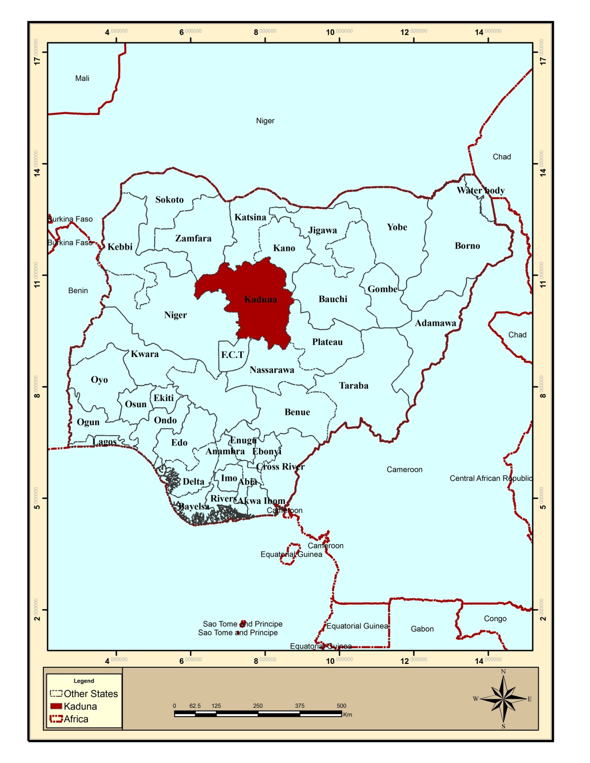

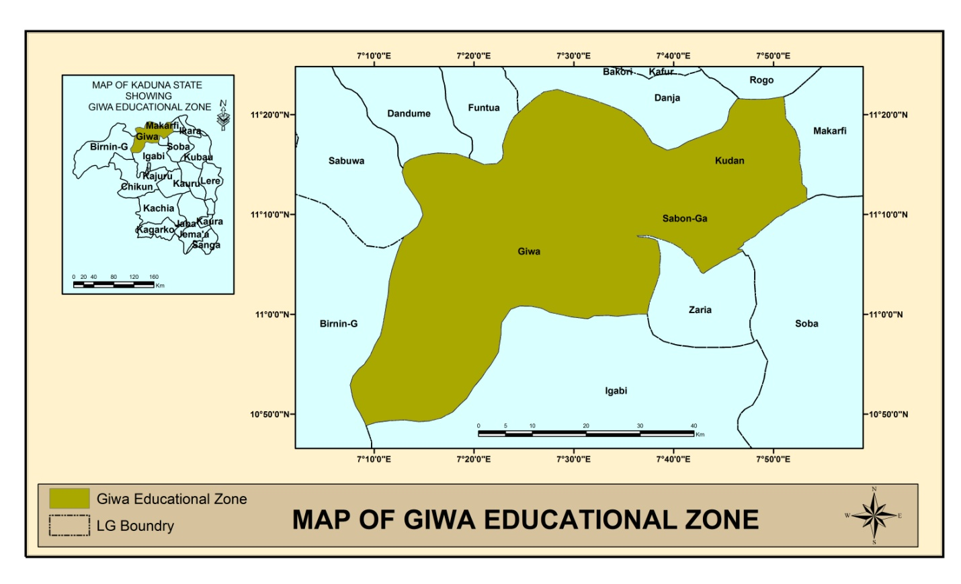

Source; Arch GIS 10.1

**CHAPTER FOUR**

**DATA PRESENTATION, ANALYSIS AND DISCUSSION**

**4.1 LOCATIONS AND PATTERNS OF SCHOOLS AND LABORATORIES IN THE STUDY AREA**

4.1.1 Map showing the location of schools in the study area

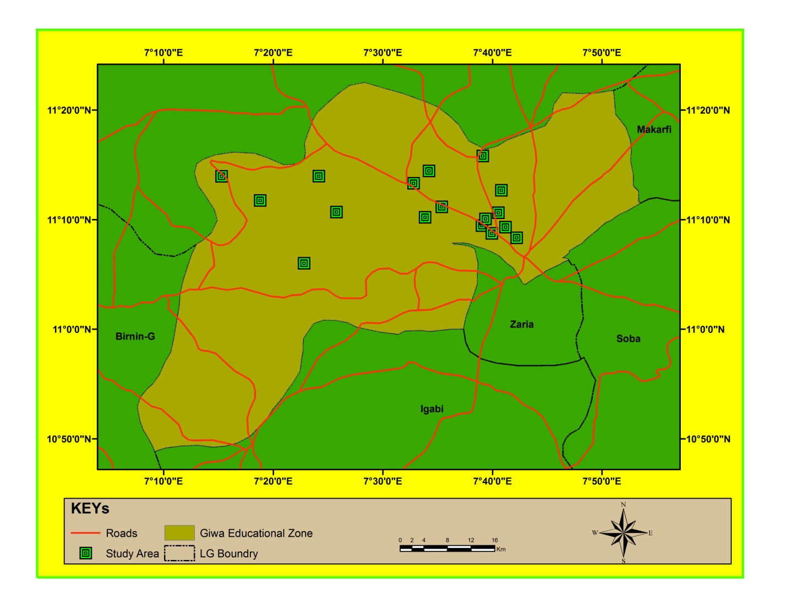

Source; field survey 2014

4.1.2 . Figure showing pattern of schools and laboratories in study area

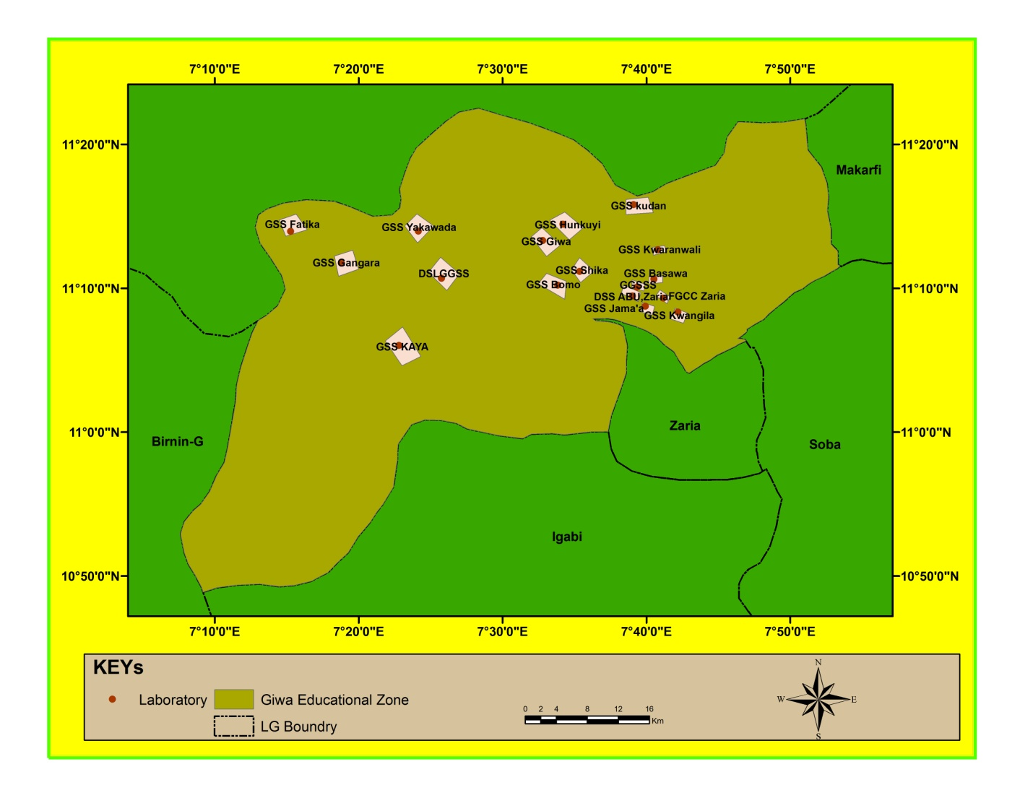

Source; field survey 2014

From the map above, it shows that, most of the schools are clustered in Sabon-Gari, dispersed in Giwa and highly dispersed in Kudan L.G.A

**4.2 Categories of LABORATORIES that exist in the Study Area**

There are two categories of laboratories that exist in the study area, namely:

1. Single purpose laboratories
2. Multipurpose laboratories

However, out of the 17 public schools in the study area, 11 are multipurpose laboratories. The maps below show the schools with single and multipurpose lab.

4.2.1 Figure 1: Thematic Map showing, schools with single purpose labs (these schools have 3 labs)

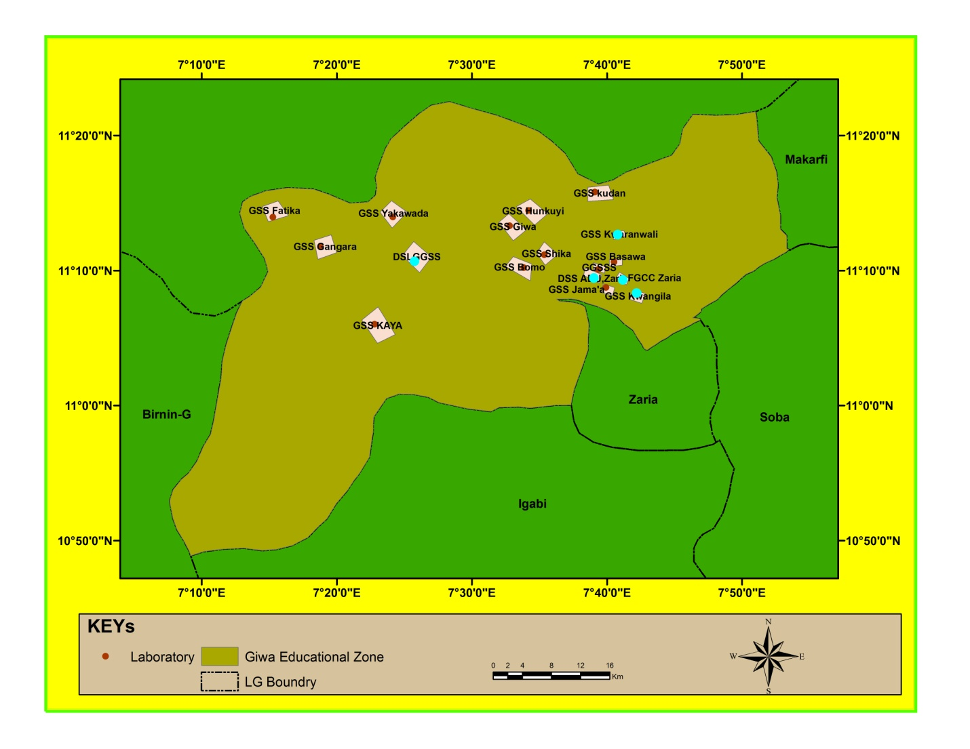

Source; field study, 2014

4.2.3 . Figure 2: Thematic map showing schools with multipurpose lab: (These schools have a single laboratory)

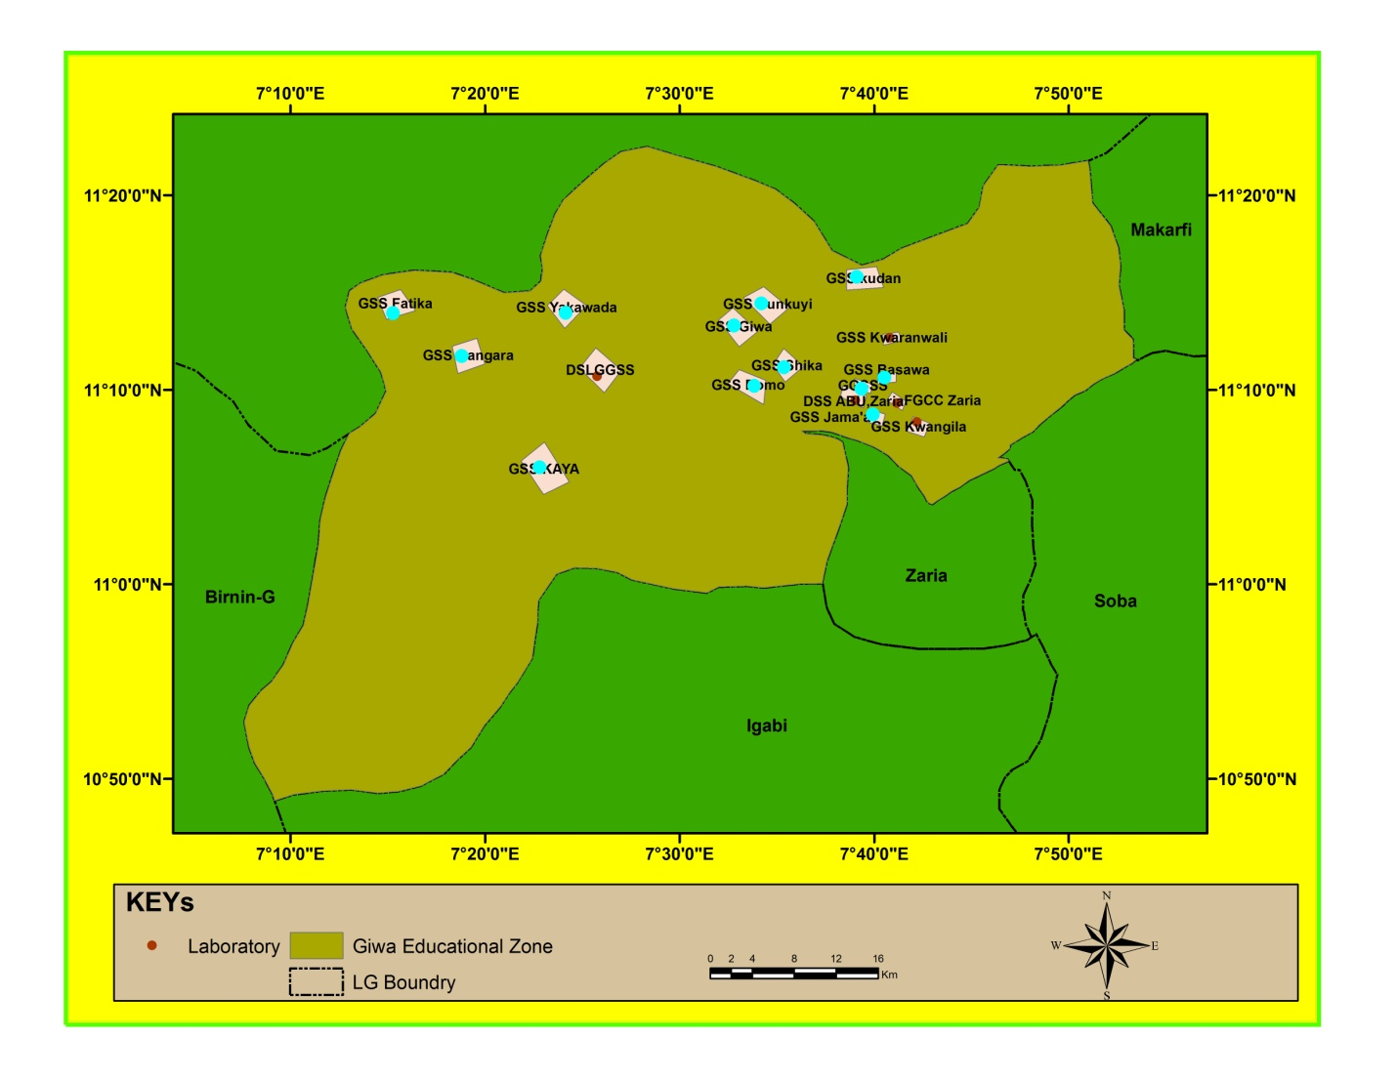

Source; field study, 2014

**4.3 Database of Laboratory Facilities in the Study Area**

The table below shows the database created for the facilities found in the laboratories of the study area;

|  |  |  |  |  |  |  |
| --- | --- | --- | --- | --- | --- | --- |
| **School** | **School easting** | **School Northing** | **Type of Laboratory** | **Lab Easting** | **Lab Northing** | **Materials** |
| DSLGSS | 7.4293 | 11.177986 | Single Purpose | 7.427664 | 11.179878 | Tables,reagents,charts,pictures,models,taps and sinks,electric circuit,microscopes |
| DSS ABU Zaria | 7.6504 | 11.157509 | Single Purpose | 7.651644 | 11.159608 | Tables,chairs, charts,models,taps and sinks,chemicals,pictures,experimental materials,wind vane,thermometer,microscopes,forceps,electric circuit |
| FGGC Zaria | 7.686263 | 11.15503 | Single Purpose | 7.684919 | 11.155592 | Tables,chairs,forceps,chart,models,taps and sinks,water supplies,windvane,thermometer,hygrometer,microscopes,electric circuit |
| GGSSS | 7.655714 | 11.167643 | Multi Purpose | 7.654373 | 11.171676 | Tables,chairs,reagent,models,electric circuit,microscope,taps and sinks |
| GSSBasawa | 7.675375 | 11.176883 | Multi Purpose | 7.675166 | 11.17854 | Tables,charts,pictures,electric,circuit,reagents,thermometer,microscopes |
| GSSFtika | 7.254597 | 11.232387 | Multi Purpose | 7.253643 | 11.231511 | Nil |
| GSSGangara | 7.313213 | 11.19555 | Multi Purpose | 7.313307 | 11.193647 | Tables,chairs,electric circuit,reagent,charts,pictures |
| GSSGiwa | 7.546537 | 11.22161 | Multi Purpose | 7.547805 | 11.221854 | Tables,chairs,taps and sinks,electric circuit |
| GSSHunkuyi | 7.569895 | 11.240626 | Multi Purpose | 7.569893 | 11.239925 | Tables,models |
| GSSJama'a | 7.665412 | 11.14548 | Multi Purpose | 7.664839 | 11.146126 | Tables, chart, electric circuit, low level reagent |
| GSSKauranwali | 7.680088 | 11.211159 | Single Purpose | 7.678034 | 11.211527 | Nil |
| GSS Kaya | 7.379877 | 11.10008 | Multi Purpose | 7.376796 | 11.102238 | Tables, electric circuit |
| GSSKudan | 7.651619 | 11.263394 | Multi Purpose | 7.64935 | 11.263447 | Nil |
| GSSKwangila | 7.703181 | 11.138895 | Single purpose | 7.703277 | 11.141249 | Nil |
| GSSShika | 7.589259 | 11.185884 | Multi Purpose | 7.589111 | 11.186571 | Tables ,chairs, reagent,models ,microscopes, thermometer,electric circuit |
| GSSYakawada | 7.402529 | 11.23267 | Multi Purpose | 7.403569 | 11.231128 | Tables,chairs,electric circuit |
| GSS-Bomo | 7.563927 | 11.169923 | Multi Purpose | 7.565016 | 11.170508 | Nil |

Source; field study, 2014

**4.4 Discussions**

Base on the data presented it shows that there are 17 public senior secondary schools in the study area. However, the schools are unevenly distributed, with Giwa and Sabon-Gari LGA having a total of 82% and Kudan LGA having 18% of the total schools found in the study area.

Also, the result shows that, there are two categories of laboratories in the study area. Namely; single purpose laboratory and multipurpose laboratory. Schools that have single purpose laboratories either have three labs or two labs, but schools that have multipurpose laboratories possess single laboratory. However the schools are dispersedly distributed going by the Nearest Neighborhood Analysis.

Finally, the database created shows that much of the schools are ill-equipped with the exception of DSS, ABU-Zaria, samaru and FGGC-Zaria.

**CHAPTER FIVE**

**SUMMARY, CONCLUSION AND RECOMMENDATIONS**

**5.1 INTRODUCTION**

The learning conditions in schools are alarming wit lack of teaching materials, laboratory materials overcrowded classroom, inadequate qualified classroom teachers, poor building materials and generally rundown condition of many of the school buildings and laboratories. In spite of the relative availability of data, educational data in study area still suffer from the following issues reported relating to quality and completeness; erroneously recorded and reported data. In consisted coding system for information on schools and teachers, prolonged periods between data collection of the study was to map out the location of schools and laboratories, identify categories of laboratories, identify categories laboratories and identify laboratory facilities as creation of database for laboratory facilities in the Giwa educational zone. The objectives was achieved through identification of public senior secondary, mapping the secondary schools with laboratories, generating the attribute data of the public senior, secondary schools and finally creating of database for senior secondary schools laboratories. The attribute data was obtained through field survey and the use of checklist developed by the researchers to observe facilities present in the laboratories. The coordinates of schools and laboratories was obtained using a hand – held GPS to show the spatial distribution of schools in the study area. Finally, GIS database was created and the spatial and the attribute data encoded and analysis carried out using Arc GIs 10.1 software. The result of the database provides the users with working environment for data management and also allows efficiency query of information need for public school management.

However this chapter provides for the summary, recommendations and conclusion for the study carried out by the researchers.

**5.2 SUMMARY OF FINDINGS**

Base on the study carried out in giwa educational zone, the following are the summary of the findings

1. The area is located between latitude 10050’ 0’’N and 11020’0’’N and longitude 7010’0’’E and 7050’0’’E.
2. There are 92 schools in the study area, 13 are public primary schools, 17 are public senior secondary schools and 62 are private schools.
3. The study also shows that there two categories of laboratories in the study area, namely; single purpose and multipurpose laboratories.
4. It also shows that 12 of the public senior secondary schools have multipurpose laboratories and 5 have single purpose laboratories.
5. The study also depicts that the public senior secondary schools in giwa educational zone are dispersedly distributed going by the nearest neighborhood analysis but then, the schools are clustered in sabon-gari, fairly dispersed in giwa and highly dispersed in kudan LGA.
6. The study in addition denotes that, most of the laboratories are either ill-equipped, dilapidated or under construction.

**5.3 CONCLUSION**

Schools are established for the purpose of teaching and learning. It is also more important that teachers and learners are properly accommodated to facilitate the teaching and learning that go on there. This is the essence of school plant and facilities (Alimi, 2004).

The consequences of mass failure in public examination are the inability of learners to proceed to higher educational institution. As a result of this poor performance stakeholders in education are curious to know the causal factors associated with the problem causes of the poor academic performance could include ownership of the school and inadequate facilities. Facilities are everything used directly and indirectly for the benefit of education. Facilities could also be explained as the entire school plants, such as block of classrooms, staffroom, laboratories, workshop, libraries, laboratory equipments, consumables, audio-visual aids, electricity, water, chairs, tables, stationeries, playground, storage spaces and others which school has. It has always been realized that laboratory facilities are very important in the teaching and learning of science. Teaching of science without experiments and practical work is like a moving car without specific direction (Ayinla, 2014).

The technological advancement of the country Nigeria cannot be attained if teaching and learning of science is not incorporated with experiments and practical, hence science should be taught as process and products and not training of the mind as it seen virtually most of our public schools in Nigeria (Ayinla, 2014).

**5.4 RECOMMENDATION**

Based on the study findings, the following are recommended.

1. Kaduna state ministry of education should give priority to public schools in equipping laboratories.
2. Science should be taught as a process and product as presumed by science teachers association of Nigeria (STAN)and to achieve this, government and stakeholders should employ teachers base on merits in different field of science who knows what a science laboratory needs for effective teaching and learning.
3. Kaduna state ministry of education should provide more funds into the system for the procurement of laboratory facilities. This responsibility lies on the educational planners and administration in the ministry of education.
4. Also, cooperate organization and individuals should be encouraged by the government to generously donate in cash and in kind for the provision of laboratory facilities for adequacy in teaching and learning of science.
5. There is need to evolve an appropriate time in the time table for teaching science in laboratories in the study area.
6. Materials used for building laboratory should be of standard quality and this could be enhanced through monitoring of contractors giving the mandate for building and supplying of laboratory facilities.